**Problem Set 4**

There are **two parts** to Problem Set 4. Complete and submit both using the Problem Set 4 Upload option in Canvas. For submission, save the files from Parts A and B in a folder, zip and upload using the upload option. Name your zipped folder as ***YourIdNum_First_LastName.zip***

**Optional Bonus Problems**:- Complete them if you would like to go for extra credit.

**Due Date**:- Midnight Monday 30th Nov, 2020 [Canvas Upload will be open till midnight 2nd Dec, 2020. Note that any uploads after midnight 30th Nov will result in a 5/30 point late-submission penalty]

**PART A**

Using the STUDENT table structure shown, do the following:

|  |  |  |  |  |  |
| --- | --- | --- | --- | --- | --- |
| **Attribute Name** | **Sample Value** | **Sample Value** | **Sample Value** | **Sample Value** | **Sample Value** |
| INV_NUM | 211347 | 211347 | 211347 | 211348 | 211349 |
| PROD_NUM | AA-E3422QW | QD-300932X | RU-995748G | AA-E3422QW | GH-778345P |
| SALE_DATE | 15-Jan-2018 | 15-Jan-2018 | 15-Jan-2018 | 15-Jan-2018 | 16-Jan-2018 |
| PROD_LABEL | Rotary sander | 0.25-in. drill bit | Band saw | Rotary sander | Power drill |
| VEND_CODE | 211 | 211 | 309 | 211 | 157 |
| VEND_NAME | NeverFail, Inc. | NeverFail, Inc. | BeGood, Inc. | NeverFail, Inc. | ToughGo, Inc. |
| QUANT_SOLD | 1 | 8 | 1 | 2 | 1 |
| PROD_PRICE | $49.95 | $3.45 | $39.99 | $49.95 | $87.75 |

1. Write the relational schema, draw its dependency diagram and identify all dependencies, including all partial and transitive dependencies. You can assume that the table does not contain repeating groups and that any invoice number may reference more than one product. (*Hint*: This table uses a composite primary key.)

1. Remove all partial dependencies, write the relational schema, and draw the new dependency diagrams. Identify the normal forms for each table structure you created.

1. Remove all transitive dependencies, write the relational schema, and draw the new dependency diagrams. Also identify the normal forms for each table structure you created.

1. Draw the Crow’s Foot ERD.

**Part B**

**Instruction**:- Create a **single .sql** file for the problems below and name it as *your* **First_LastName_PS4.sql**. Include your .sql file in the zipped folder as mentioned in the **Submission** section on Page 1.

Use the ERD diagram below to answer parts Q1-10 below. You can create tables and insert data using the file **PS4_Datafile.txt** provided under the **Problem Set 4 sectio**n in Canvas.

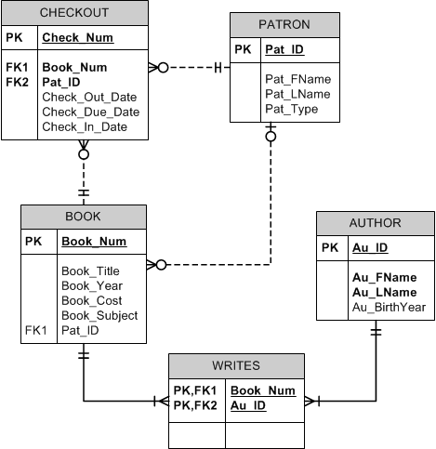

1. Write a query that displays the first and last name of every patron, sorted by last name and then first name. Ensure the sort is case insensitive (50 rows)

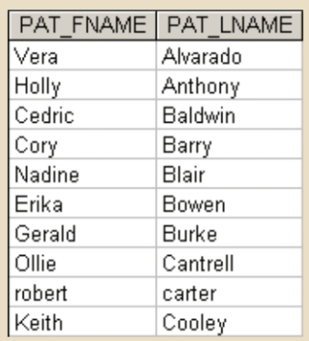

1. Write a query to display the checkout number, checkout date, and due date for every book that has been checked out sorted by checkout number

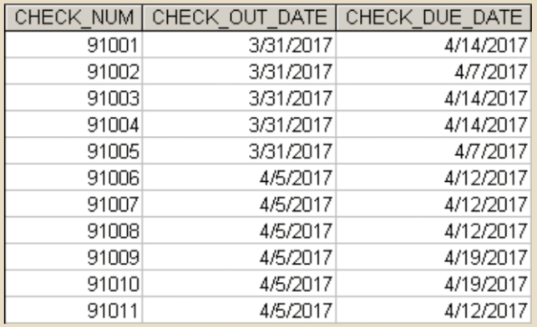

1. Write a query to display the book number, book title, and subject for every book sorted by book number

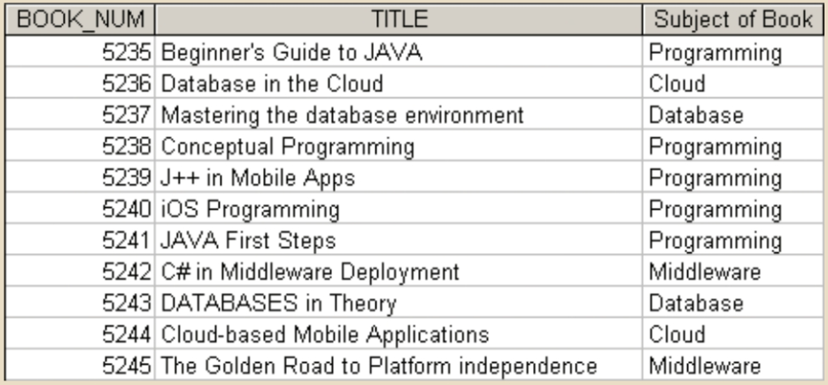

1. Write a query to display the book number, title, and cost of each book sorted by book number

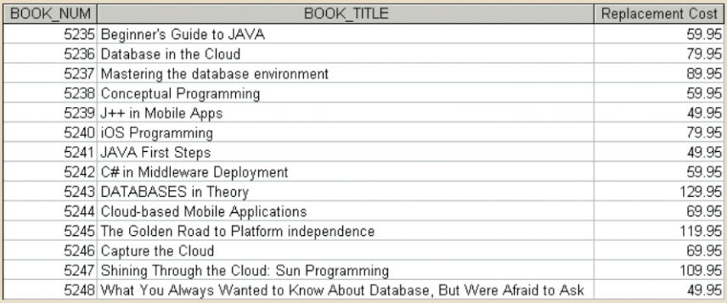

1. Write a query to display the checkout number, book number, patron ID, checkout date, and due date for every checkout that has ever occurred in the system. Sort the results by checkout date in descending order and then by checkout number in ascending order.

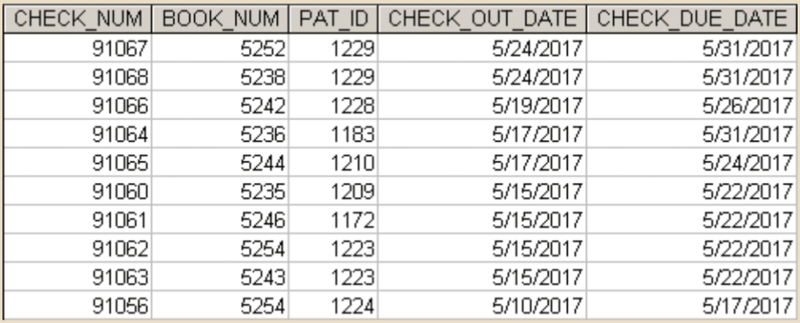

1. Write a query to display the book number, title, and replacement cost for all books in the “Database” subject sorted by book number

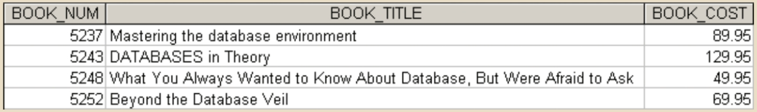

1. Write a query to display the checkout number, book number, and checkout date of all books checked out before April 5, 2017 sorted by checkout number

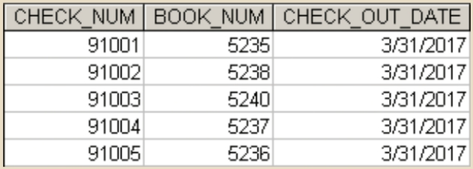

1. Write a query to display the checkout number, book number, patron ID, checkout date, and due date for all checkouts that have not yet been returned. Sort the results by book number

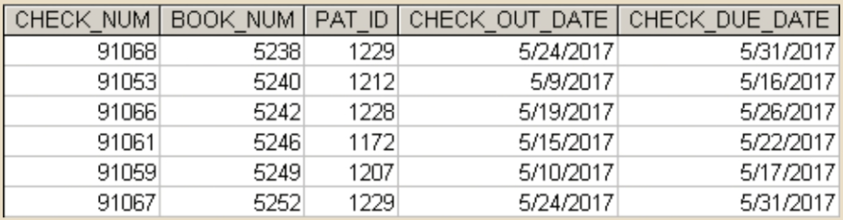

1. Write a query to display the author ID, first name, last name, and year of birth for all authors. Sort the results in descending order by year of birth, and then in ascending order by last name

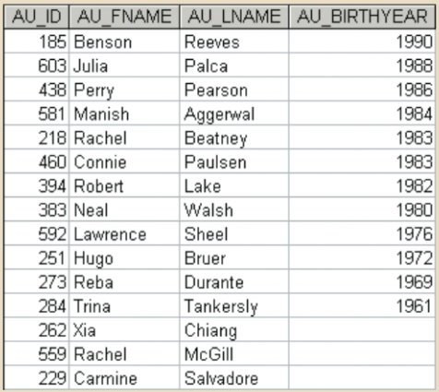

1. Write a query to display the subject and the number of books in each subject. Sort the results by the number of books in descending order and then by subject name in ascending order

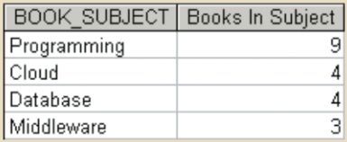

**Optional Bonus Problems**:- Complete these questions for extra credit – questions are worth 3 points each.

1. Write a query to display the author ID and the number of books written by that author. Sort the results in descending order by number of books, then in ascending order by author ID.

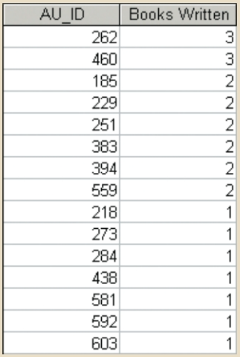

1. Write a query to display the patron ID, book number, and days kept for each check-out. “Days Kept” is the difference from the date on which the book is returned to the date it was checked out. Sort the results by days kept in descending order, then by patron ID, and then by book number.

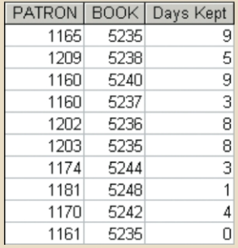

1. Write a query to display the book number, title with year, and subject for each book. Sort the results by the book number.

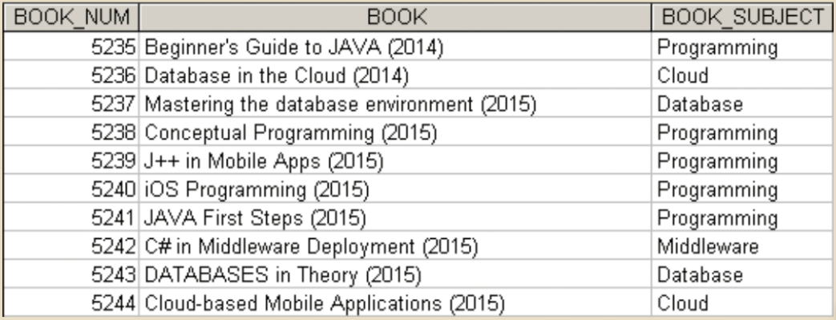

1. Write a query to display the author last name, first name, book title, and replacement cost for each book. Sort the results by book number and then author ID.

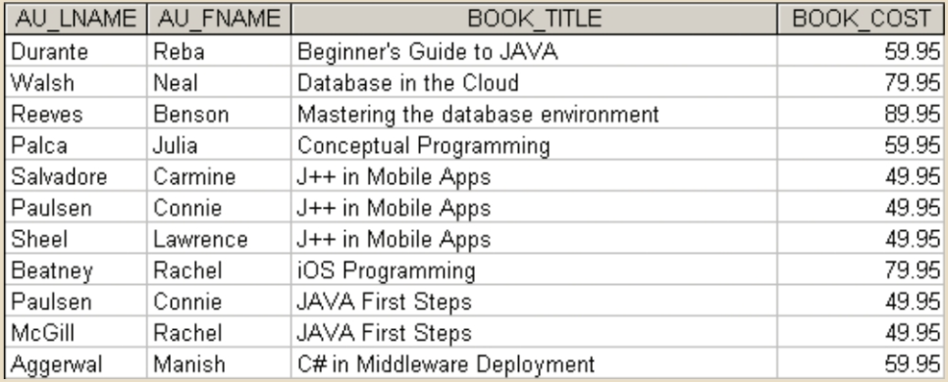

1. Write a query to display the book number and the number of times each book has been checked out. Do not include books that have never been checked out. Sort the results by the number of times checked out in descending order and then by book number in descending order

